Three-Switch Office Network Lab: Project Brief
Oct 6, 2026 · @blake

Scenario and constraints
This project builds a segmented small-office network with a collapsed core design: one Cisco Catalyst Layer 3 core switch and two Layer 2 access switches, validated through planned failure tests.
How this brief was created: I asked Claude, an AI assistant made by Anthropic, to write these requirements so I could simulate a client project on real hardware. Claude provided the goals and acceptance criteria only. I designed the implementation, wrote every configuration, ran every test, and wrote the documentation myself.
The simulated client is a small office with users and servers spread across two access switches. It needs:
- Users, servers and network management on separate networks, with the same user network available on both access switches
- Redundant uplinks from each access switch to the core, plus a backup path that takes over if an access switch loses its uplink entirely
- All routing, gateways and DHCP centralized on the core switch
- Internet access through an existing upstream router, without the office network extending onto or interfering with the upstream network
- Secure remote management, centralized logging and configuration backups
Constraints: three Catalyst switches (one operating as the Layer 3 core, two operating as Layer 2 access switches with no routing), one Ubuntu server, one test laptop, and a consumer home router as the only path to the internet. All work is done on physical hardware, not in a simulator.

Topology and addressing
SW1 is the Layer 3 core: the spanning tree root, the gateway for every VLAN, and the only device connected to the home router. SW2 and SW3 are Layer 2 access switches that only switch traffic up to SW1.
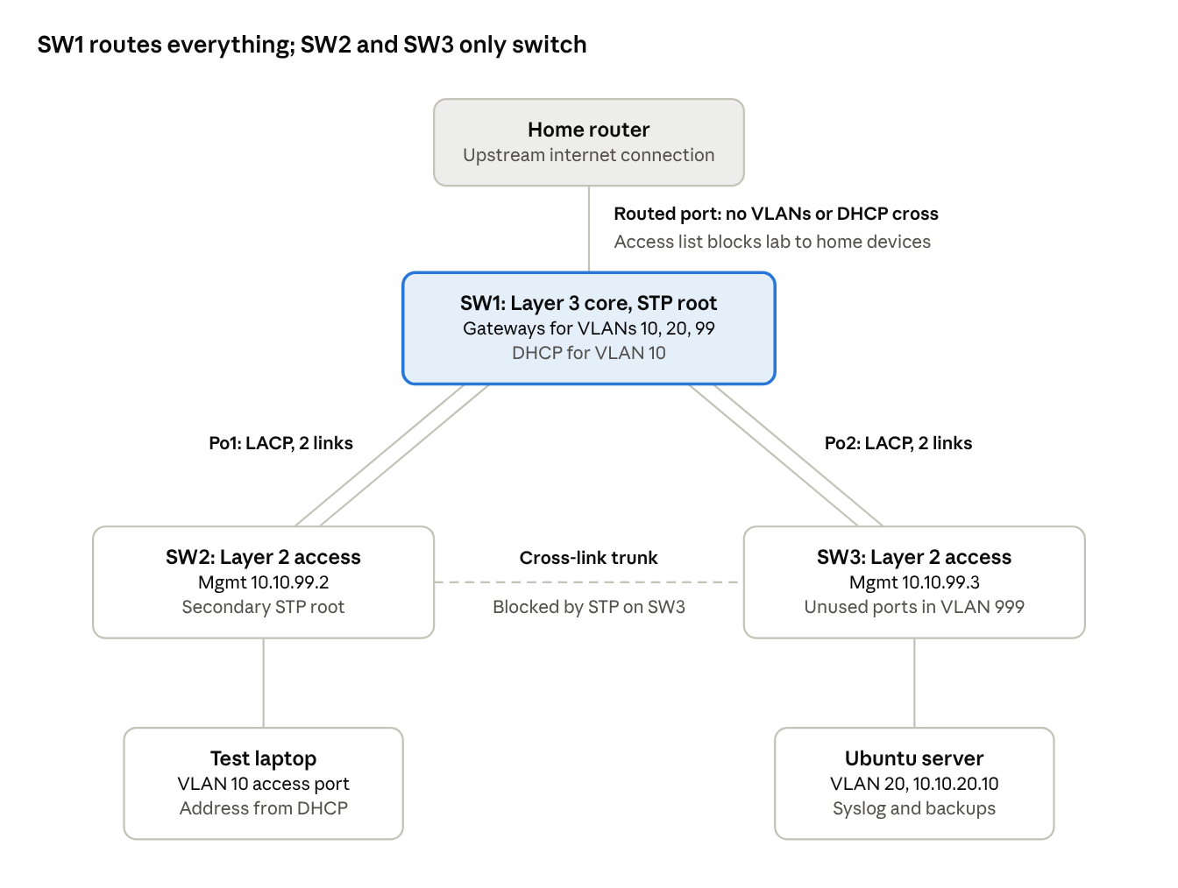
lab topology · 1 core switch, 2 access switches, home router uplink
Each access switch has a two-link EtherChannel to the core, so a single cable failure doesn't interrupt traffic. The cross-link between SW2 and SW3 stays blocked by spanning tree during normal operation and takes over only if an access switch loses both of its uplinks. Every trunk carries VLANs 10, 20 and 99 with VLAN 900 as native.
VLAN | Name | Subnet | Gateway | Purpose
10 | USERS | 10.10.10.0/24 | 10.10.10.1 | User devices on either access switch, addressed by DHCP
20 | SERVERS | 10.10.20.0/24 | 10.10.20.1 | Ubuntu server, static 10.10.20.10
99 | MGMT | 10.10.99.0/24 | 10.10.99.1 | Switch management: SW1 .1, SW2 .2, SW3 .3
900 | NATIVE | none | none | Trunk native VLAN, carries no hosts
999 | PARKING | none | none | Unused ports, shut down
Uplink | none | Home network | Home router | SW1 routed port to the home router

Requirements
Each requirement is complete only when its acceptance criteria are met and the verification output is saved in the repo.
# | Requirement | Accepted when | Status
1 | Clean baseline | All three switches are inventoried (model, software, capabilities) and reset to a blank configuration | Not started
2 | Secure management | Every switch has a hostname, encrypted privileged password, local user login and banner; remote access is SSH version 2 only and Telnet is refused | Not started
3 | Segmentation | VLANs 10, 20 and 99 exist on all three switches; every unused port is in VLAN 999 and shut down | Not started
4 | Redundant core uplinks | Each access switch connects to the core through its own two-link LACP EtherChannel; each trunk carries only lab VLANs, uses VLAN 900 as native and does not negotiate trunking | Not started
5 | Access cross-link | A single trunk between SW2 and SW3 provides a backup path to the core | Not started
6 | Spanning tree | Rapid PVST+ runs everywhere; SW1 is root for every lab VLAN and SW2 is secondary root; the cross-link is blocked on SW3's side; edge ports use PortFast and BPDU Guard | Not started
7 | Centralized routing | SW1 is the only routing device and the gateway for every VLAN; SW2 and SW3 have only a management address and a default gateway; a VLAN 10 device on SW2 reaches the server on SW3 | Not started
8 | DHCP | SW1 assigns VLAN 10 addresses to devices on either access switch, reserving .1 through .20, with the correct gateway | Not started
9 | Logging and backups | The Ubuntu server receives timestamped syslog from all three switches and stores all three running configurations | Not started
10 | Internet access | Lab devices reach the internet through the home router over a routed port on SW1; lab VLANs and DHCP stay off the home network, and an access list blocks lab devices from home devices | Not started
11 | Access-layer security (optional) | User ports on both access switches allow one learned device, and DHCP snooping protects VLAN 10 on both, trusting only the paths toward SW1 | Not started

Validation and failure testing
Each test runs during a continuous ping from the test laptop on SW2 to the server on SW3, and the observed result is recorded alongside the pass criteria.
Test | What it proves | Pass criteria | Result
One link in SW2's EtherChannel fails | EtherChannel redundancy | Traffic continues over the remaining link and the bundle stays up
SW2 loses both core uplinks | Backup path through the cross-link | Spanning tree unblocks the cross-link and traffic reaches the core through SW3; convergence time is recorded
SW2's uplinks are restored | Recovery to the normal path | Traffic returns to SW2's own uplinks and the cross-link blocks again
Cross-link role check | Spanning tree design | The cross-link port on SW3 is blocking while SW2's side is forwarding
BPDU received on an edge port | Loop protection | The port is error-disabled and the event is logged
Native VLAN mismatch | Trunk misconfiguration detection | The mismatch is detected and logged by the switches
Root bridge change | Spanning tree control | The root moves as configured, the blocked port changes accordingly, and both return when priorities are restored
Lab device attempts to reach a home device | Access list enforcement | The connection is blocked while internet access still works
Second device on a secured port (optional) | Port security | The violation is detected and logged

Deliverables
The GitHub repository contains:
- A README with design decisions and the reasoning behind each one
- A topology diagram and addressing plan
- Sanitized running configurations for all three switches, with all credentials removed
- Verification output for each requirement
- Failure test results, including measured convergence times
- A troubleshooting log of problems hit during the build, how each was diagnosed, and the fix

Skills demonstrated
Area | Requirements | Skills
Network design | 4, 5, 7 | Collapsed core design, separating Layer 3 core and Layer 2 access roles, redundant paths
Switching | 3, 4, 5, 6 | VLANs, 802.1Q trunking, LACP EtherChannel, Rapid PVST+ root and port role control, PortFast, BPDU Guard
Routing | 7, 10 | SVIs, centralized inter-VLAN routing, routed ports, static default routing
Network services | 8, 9 | DHCP across multiple access switches, syslog, TFTP configuration backups, Linux server administration
Security | 2, 10, 11 | SSH hardening, access lists, port security, DHCP snooping trust boundaries
Operations | All | Failure testing, convergence measurement, structured troubleshooting, technical documentation

